CYBER SECURITY TASK 01
Part E: Cybersecurity Awareness Poster

Topic: Phishing Awareness

Submitted By
Pratiksha Vishwakarma
Internship Cybersecurity Task · Personal Security Audit & Cyber Awareness Assessment

Poster Design Brief

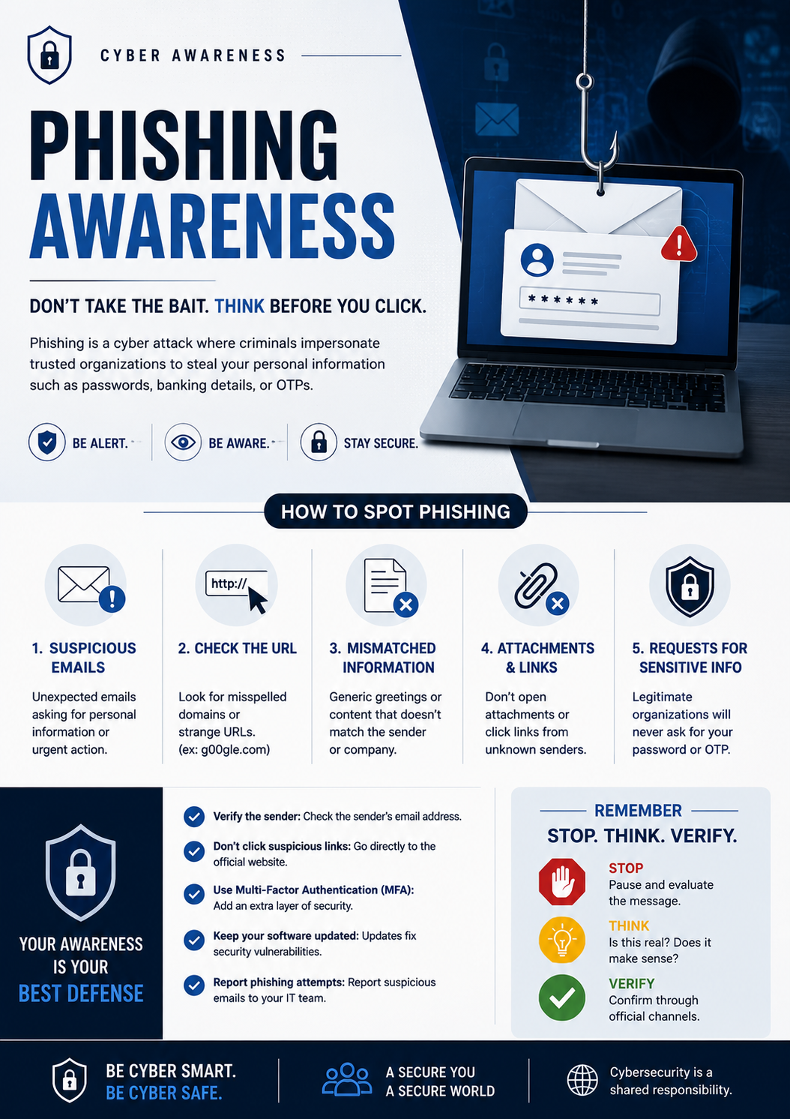
Field | Details
Topic Selected | Phishing Awareness
Target Audience | General internet users, students, and office employees
Key Message | Stop, Think, and Don't Click — always verify before you trust any link or request
Design Approach | Bold red (danger/alert) contrasted with green (safe actions) on a clean white layout
Design Tools | Designed as a Word document — fully reproducible in Canva, PowerPoint, Figma, or Photoshop

⚠ PHISHING AWARENESS ⚠
STOP · THINK · DON'T CLICK
Protect Yourself — Verify Before You Trust

What is Phishing?
Phishing is a cyberattack where criminals disguise themselves as a trusted organisation — a bank, tech company, or government body — to steal your passwords, personal data, or money through fake emails, links, or websites. It is the most common entry point for cyberattacks globally and can affect anyone at any time.

⚠ Warning Signs of a Phishing Message
Warning Sign | What to Look For — Example
Urgency or Threats | "Your account will be permanently suspended in 24 hours — act now!"
Suspicious Sender Address | "support@paypa1-security.net" — note the digit "1" replacing the letter "l"
Generic, Impersonal Greeting | "Dear Valued Customer" — instead of your actual full name
Mismatched or Fake Links | Displayed URL ≠ actual destination — always hover over links first to verify
Unexpected File Attachments | Unsolicited and unexpected .zip, .exe, .pdf, or .docx files in emails
Requests for Sensitive Data | "Verify your password, bank details, or SSN immediately to avoid suspension"

✔ How to Stay Protected
✅ Never click suspicious links — always type website addresses directly into your browser address bar.
✅ Verify the complete sender email address carefully before replying to or acting on any message.
✅ Never enter passwords on a website you reached by clicking a link inside an email.
✅ Enable Multi-Factor Authentication (MFA) on all important accounts — banking, email, and social media.
✅ Report any suspicious email immediately to your IT team or email provider — do not ignore it.
✅ When in doubt about a communication, call the organisation using their official, publicly listed number.
✅ Keep your browser, antivirus software, and operating system fully updated at all times.

Think Before You Click. Stay Cyber Safe.
If it looks suspicious — it probably is. Report it. Don't click it.

Cyber Security Task 01 · Part E: Cybersecurity Awareness Poster · Pratiksha Vishwakarma · Topic: Phishing Awareness

